<https://github.com/LETHANHNHADV19/KTPMUD_DV19_CK.git>

cau 3

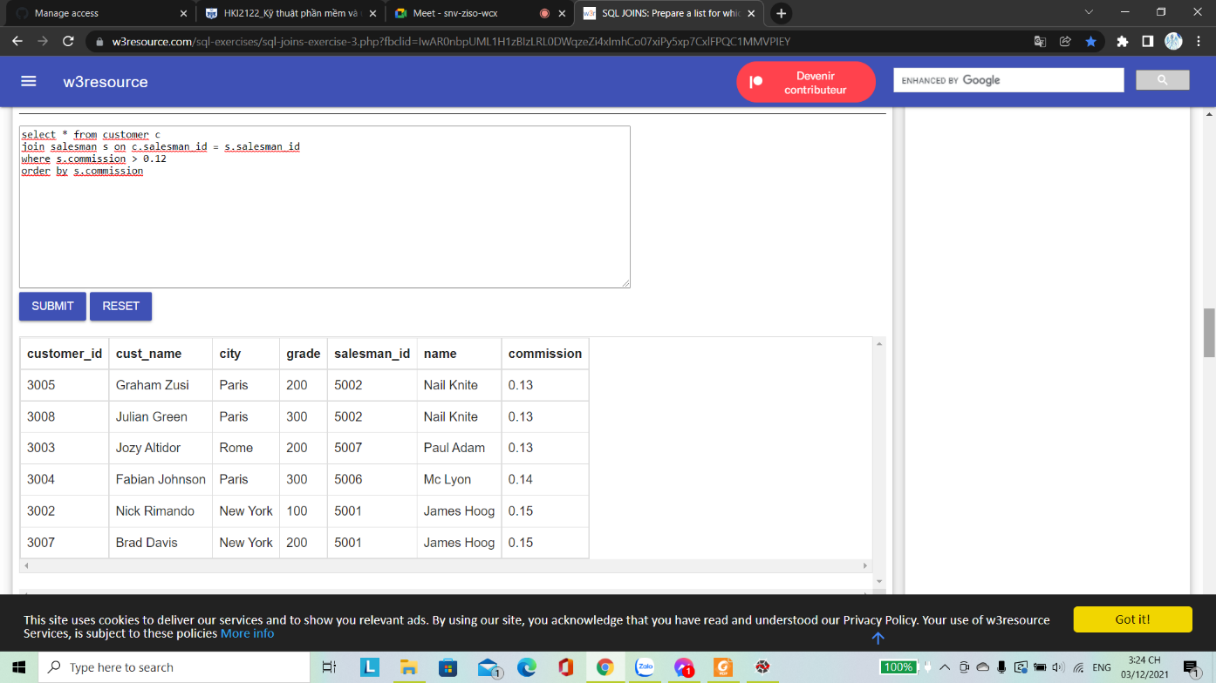

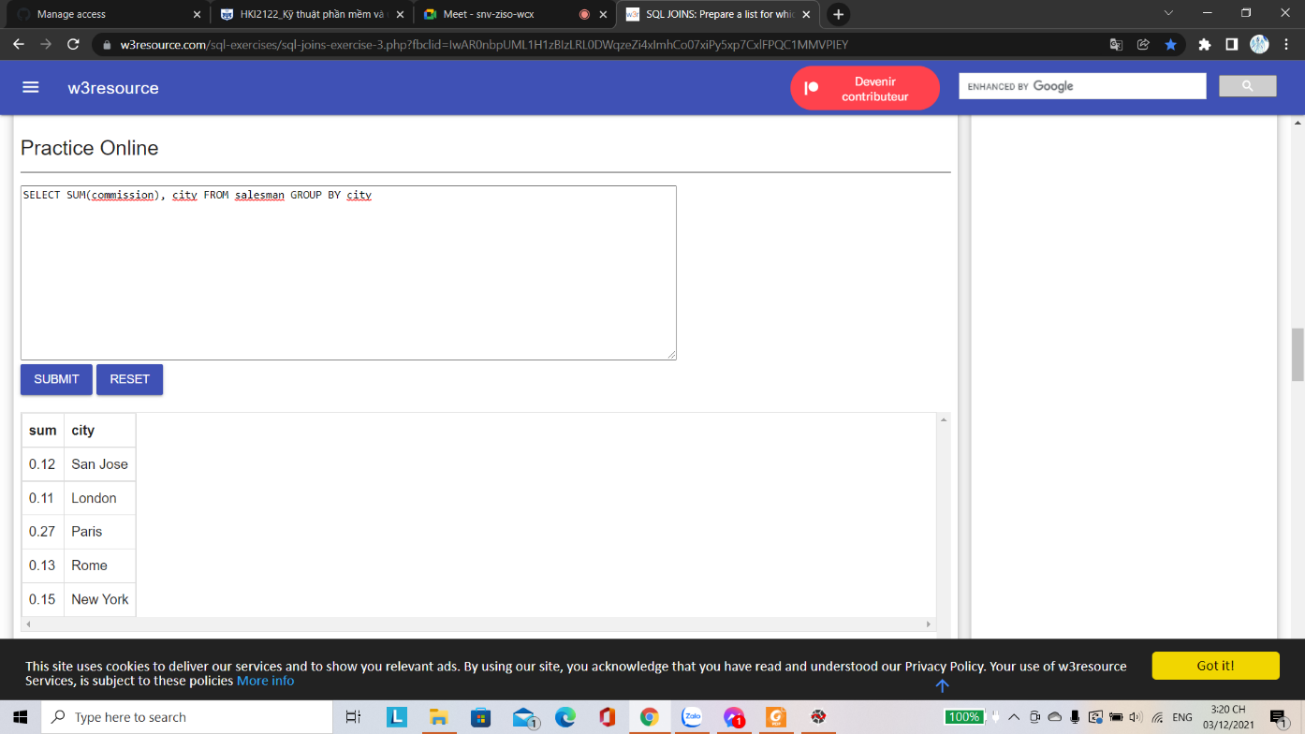

Cau 2